Step :1 Install SonarQube Server on WSl
- Requirements for this are
  - Must have JDk 17 and above in wsl
    - sudo apt update
    - sudo apt install openjdk-17-y
    - java –version
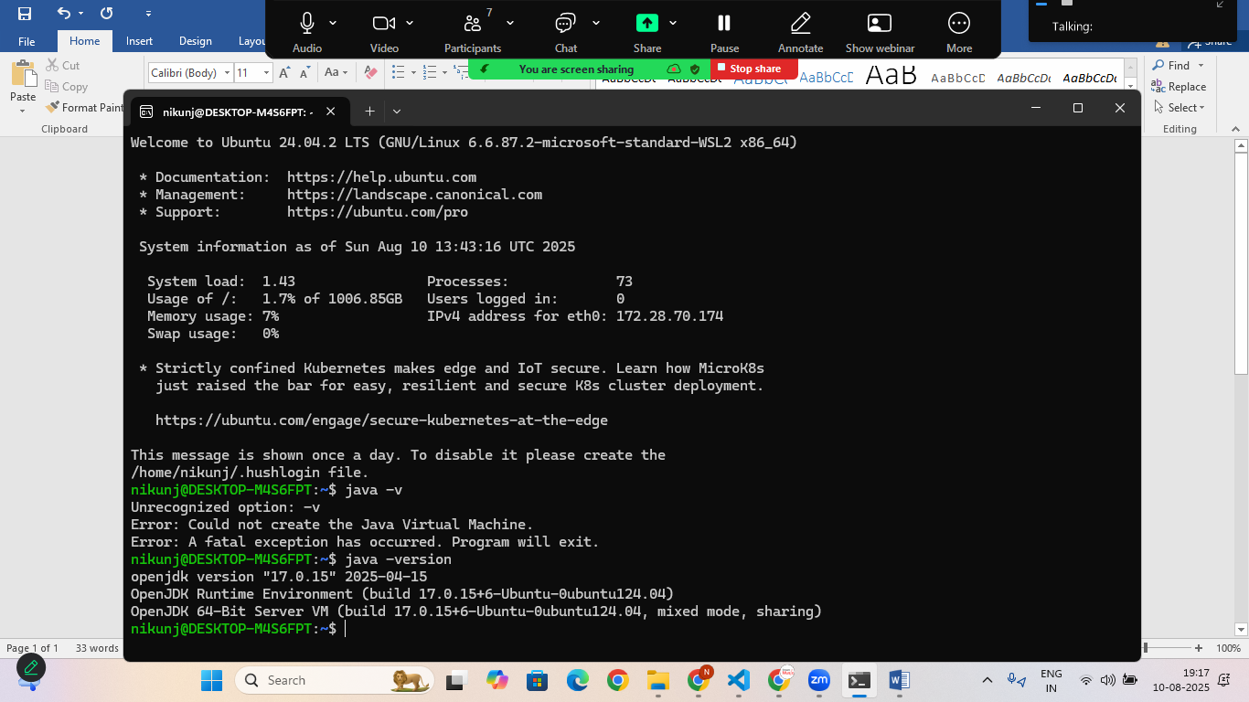
Step:2 Install PostgreSQL
- sudo apt install postgresql postgresql-contrib –y
Now Create SonarQube DB and User:
- sudo –u postgres psql
- CREATE USER sonar WITH PASSWORD ‘sonar’
- CREATE DATABASE sonarqube OWNER sonar;
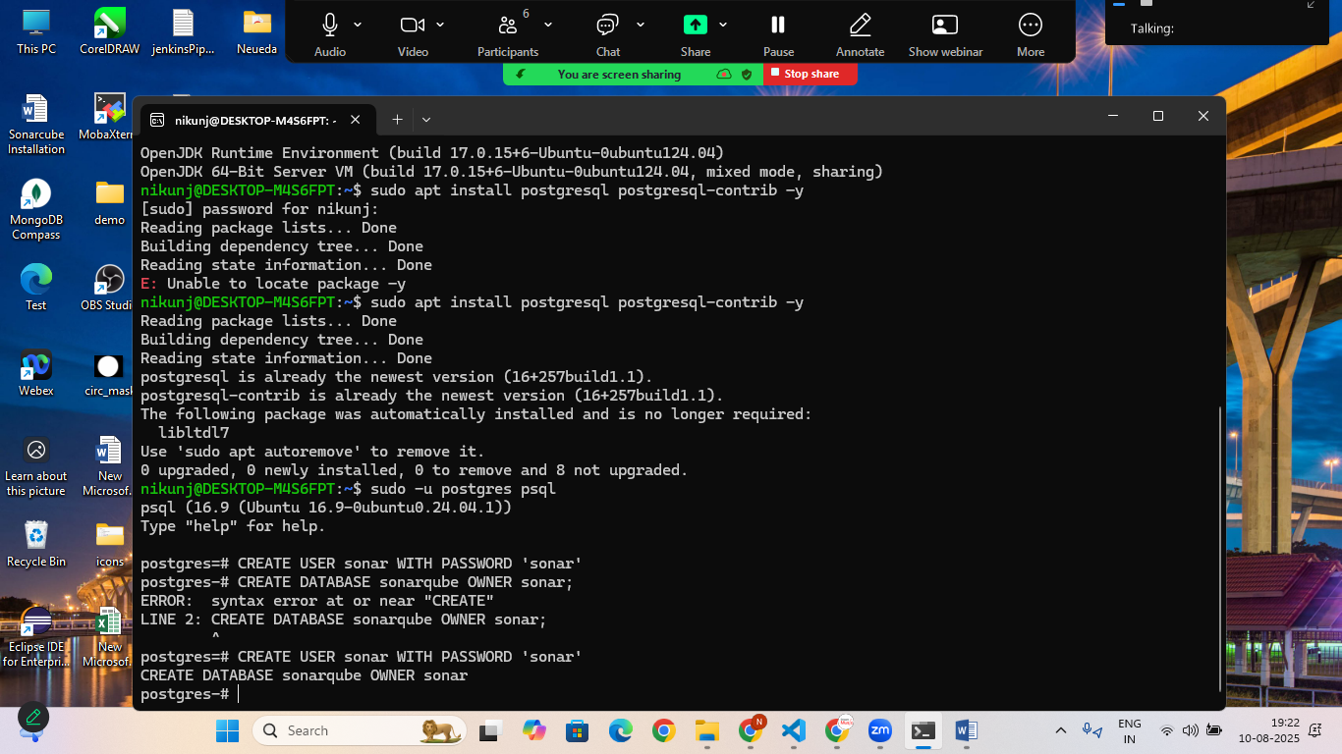
- \q
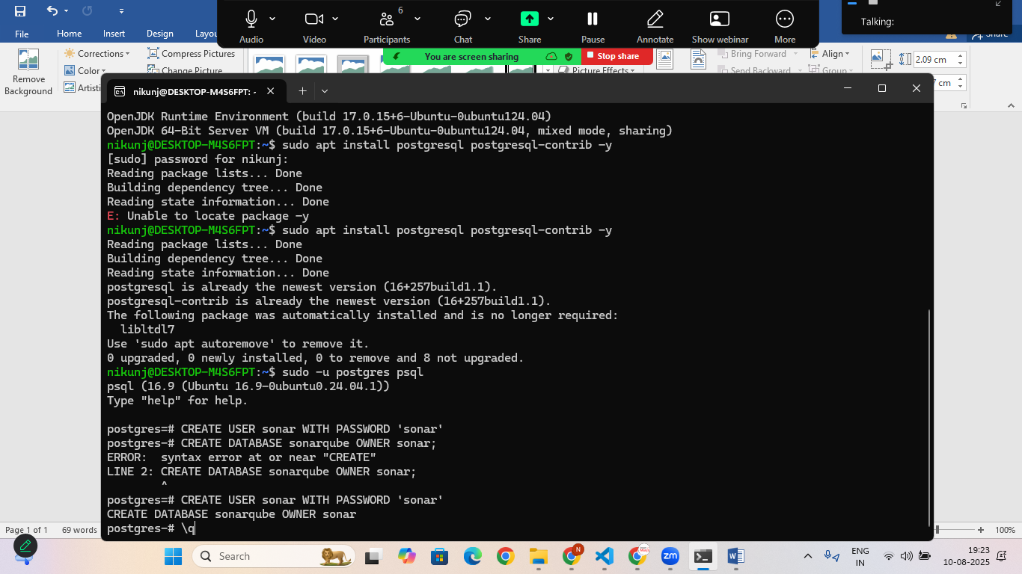

Step:3 Install required Dependencies
- sudo apt install unzip wget gnupg2 –y
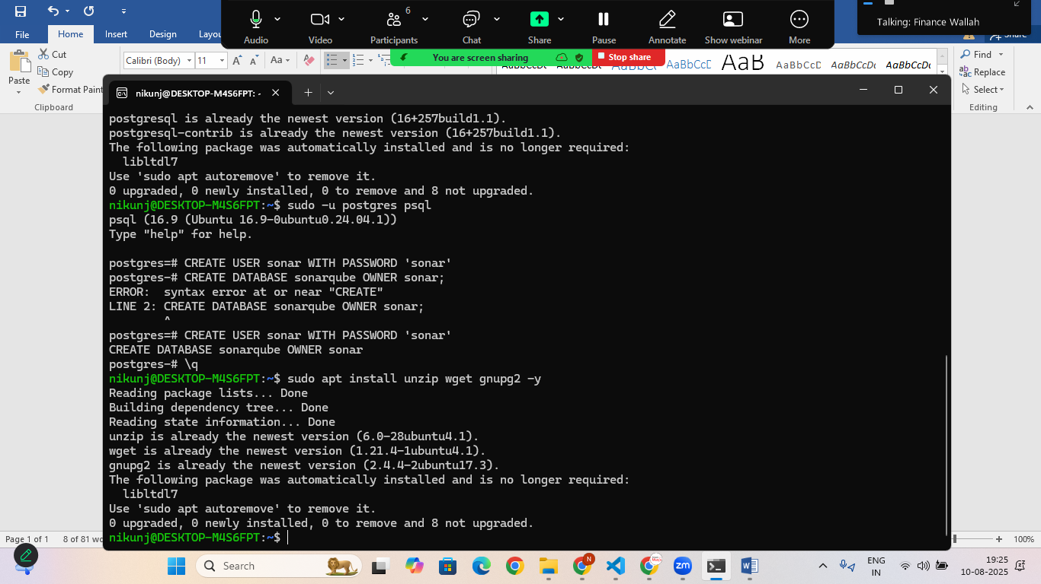
- sudo wget https://binaries.sonarsource.com/Distribution/sonarqube/sonarqube-10.5.1.90531.zip
- sudo unzip sonarqube-10.5.1.90531.zip
- sudo mv sonarqube-10.5.1.90531.zip sonarqube
- sudo chown –R $USER:$USER sonarqube
- nano /opt/sonarcube/conf/sonar.properties
(if opt folder is not available create using command “mkdir opt”)
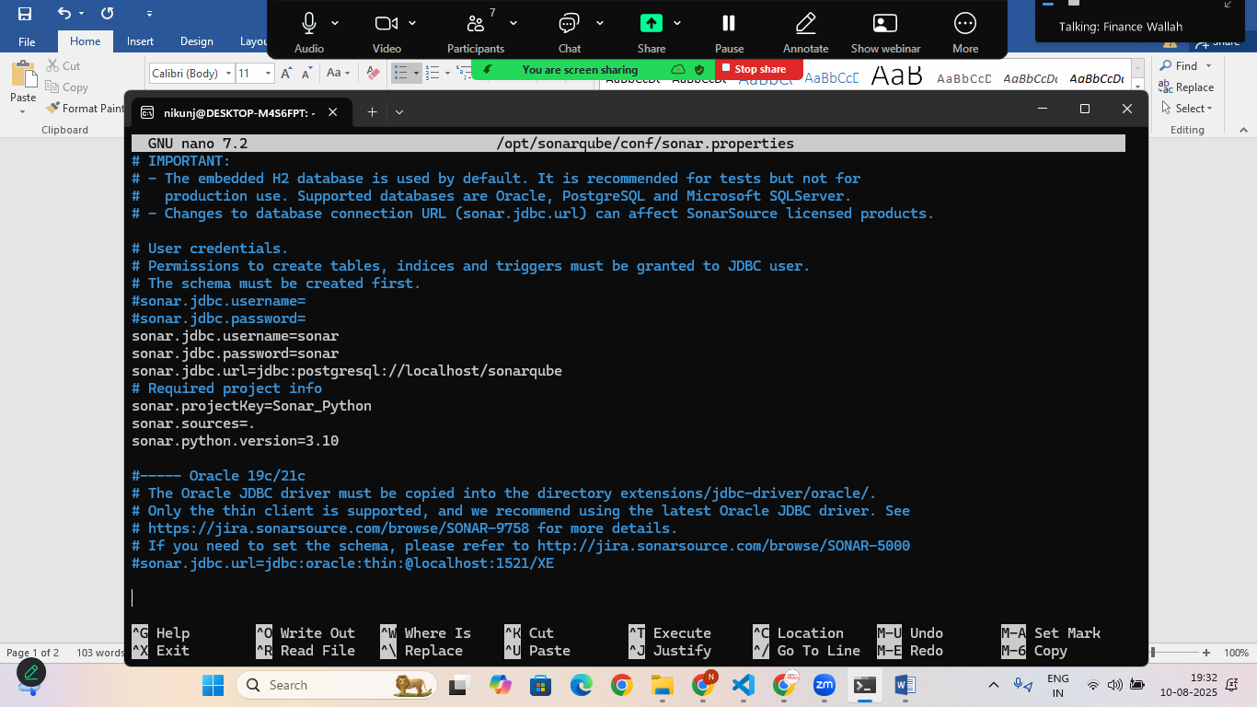

sonar.jdbc.username=sonar
sonar.jdbc.password=sonar
sonar.jdbc.url=jdbc:postgresql://localhost/sonarqube
# Required project info
sonar.projectKey=Sonar_Python
sonar.sources=.
sonar.python.version=3.10

Step: 5 Run the sonarqube
- cd /opt/sonarqube/bin/linux-x86-64
- ./sonar.sh start
- ./sonar.sh status

